The Albion Surgery Newsletter
January 2020

What’s new in the surgery?  New joiners  We are pleased to welcome our new practise nurse Sharon Lynch.  Leavers  Dr Abbas will be leaving the Practice on 11th March 2020. She has been a Partner at the Practice for 4 years after initially training with us. We wish Dr Abbas well for her future plans and know she will be greatly missed by staff and patients.  Dr Stoate our Senior Partner will be retiring from the practice at the end of April after 38 years as a Partner. He will be greatly missed by staff and patients. We wish him a long and happy retirement.  If patients would like to contribute to leaving presents please let our reception team know who will make a note of your details and contribution to the collection.  For your information | 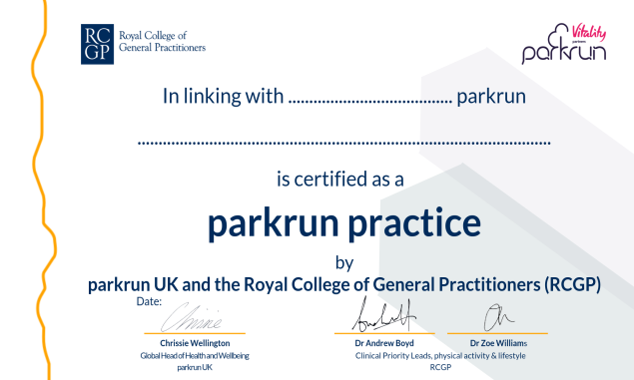  FREE healthy heart checks

We believe strongly in patient health promotion and offer comprehensive checks to all our new patients. We are also pleased to be able to offer health checks for all patients between 40-74, who do not have any existing conditions such as, diabetes, hypertension or coronary heart disease and have not had a health check in the last 5 years.
If you are interested in having a free healthy heart check, please make an appointment to see the Health Care Assistant Lorraine.
Patient Access is a great resource for you to book appointments with the GP, see future appointments and order repeat medication. If you have not already and would like to sign up for Patient Access, please see reception who will happily set up your Patient Access and email your codes.
For this you will need to bring in: photographic ID (passport, driving license or freedom pass) and one document dated within the last 3 months as proof of current address (utility bill or bank statement).
Child proxy
Parents have been receiving an email from our system provider, to inform them that children aged 11-16 years can consent to their parents making appointments etc on their behalf. As a practice, we have a protocol in place where a child would need to sign a consent form stating they are happy for their parents to have access to their account.
Please note that once a child reaches the age of 16, they have their own account with their own email access. We do not accept consent for proxy at 16 or above, unless they are extenuating circumstances which can be discussed.
Consent forms are available at reception.
The Albion Social Club
The Albion Social Club meet the 1st and 3rd Tuesday of every month from 6-8pm. Feel free to come along and talk over a cup of tea, all new members are welcome.

Patient guide

Appointment System
We have 4 different types of appointments at The Albion Surgery, they are:-

Pre-bookable Appointments
We are also pleased to announce that advance booking for a doctor or nurse has been increased to 4 weeks.

Book on the Day Appointments
These appointments are available from 8am each morning.

Emergencies
These are passed to the duty doctor who will either call the patient or ask reception to make an appointment for them to attend the surgery.

Please phone before 11am if you want to be seen that day.

Internet Appointments
80% of appointments are now available on line on a daily basis. To access this service, patients can speak to a receptionist for information on how to register for this system or can access information via the practice website.

GP Hub
We can now offer an extended appointment service via the GP hub.
Locations are based at Queen Mary’s Hospital and Erith Hospital during Monday-Friday, 6.30pm-8.00pm and Saturday- Sunday 8.00am-8.00pm. Appointments can be made by phoning the surgery and asking a receptionist to check availability. Appointments can be booked up to two weeks in advance.

Checking in Machine
Patients are reminded to use the checking in machine which is located next to the reception window. Patients sometimes find the system slow, but are encouraged to use with patience.

Contacting patients
We are currently updating all patient contact details and would be grateful if you could inform us of any relevant telephone numbers, in particular mobile numbers and e-mail addresses.

We are registered with IPLATO which is an electronic texting service. We are now able to remind patients of their appointment date and time. Patients can also cancel their appointments using this system. In the future, we will be using this method to inform patients of our flu clinics and any other services we feel should be communicated in this way eg Patient Participation Group news.

Reports
Please note that patients’ requests for paperwork, eg, private letters, insurance claims and holiday cancellations etc will incur a standard set fee.

A list of current fees can be obtained from reception. If you are unsure of the cost, please ask to speak to a receptionist who will check this for you.

Prescriptions
There are new changes to the way you can order your prescription.

You can request new and repeat prescriptions via the Albion Surgery website, Patient Access or by completing a repeat request form available in reception.

Prescriptions will be ready to collect within 3 working days – either EPS from your chemist or in the surgery.

Not attending or cancelling appointments
Patient demand for appointments has increased significantly over the last year. We try to accommodate where we can, however, a recent audit has shown that up to 50 appointments are lost per week because patients fail to inform us that they no longer require their appointment.

We are now sending letters to patients who fail to attend without informing us, repeat offenders are at risk of being removed from our practice as we now have to take this seriously. Updated posters show information on how many appointments are lost each week for your information.

Please help us to help our patients by informing us as soon as possible if you no longer need your appointment. We can then offer this to someone who is in need of seeing their doctor or nurse.

MOBILE PHONE NUMBERS/E-MAIL ADDRESS
If you haven’t already given us your mobile phone number or e-mail address, please ensure that you provide this information at your next visit.

Patient Participation Group (PPG)

Our Patient Participation Group has now been running for 5 years and we have an established Group of members. You may have seen them in the foyer area fundraising and communicating with patients about the group. The group is a member of NAPP (National Association for Patient Participation).

The group is involved with fundraising for the Practice and for various charities. They provide a patient voice towards patient services.

All of our patients are automatically members of this group if you want to be involved more please leave your details with the reception team and a member of the group will contact you.

We are always seeking new members who can bring their individual ideas to the group and represent their age groups.

Young mums or dads – joining the PPG would enable you to have a voice

Teenagers – we are seeking teenagers to join the PPG and would welcome virtual members to the group as your ideas are just as important.

Please give reception your details and a member of the PPG will contact you with more information

We would like to thank the PPG for all their hard work in continuing to support the practice.

Reminders
In the surgery car park – this is strictly for Doctors and staff only – any unauthorised parking will be subject to a fine or police action – as it has now become necessary to enforce parking restrictions.

Please note we are not responsible for any damage to vehicles that are parked illegally on our private land.
CCTV now operates in our staff car park and the main entrance to the practice.

